
Student Number
Mark / 100

2008

TRIAL HSC ANSWERS
EXAMINATION

Chemistry

General Instructions

•Reading time – 5 minutes
•Working time – 3 hours
•Write using black or blue pen
• Draw diagrams using pencil
•Write your Student Number at the top of this page and on the response sheets on pages ...
•Board-approved calculators may be used
•A data sheet and a Periodic Table are provided at
the back of this paper. This may be removed for your
convenience.
•Write your Student Number at the top of this page
and those of .....

Total Marks – 100

Section I Pages....

75 marks

This section has two parts, Part A and Part B

Part A – 15 marks
•Attempt Questions 1-15
•Allow about 30 minutes for this part

Part B – 60 marks
•Attempt Questions .........
•Allow about 1 hour and 45 minutes for this
part

Section II Pages ......

25 marks

•Attempt Question.29
•Allow about 45 minutes for this section
Confidential
Keep Secure

Section I
75 marks

Part A – 15 marks
Attempt Questions 1-15
Allow about 30 minutes for this part

Use the multiple choice answer sheet on page .....
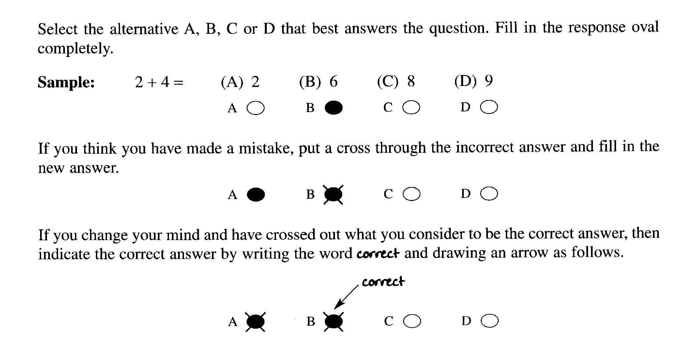

Mark your answers on the ANSWER grid on page.............
________________________________________________________________________________
1. Which is the most common catalyst for the manufacture of ethanol from ethene and water? Outcome: H8

(A) Yeast
(B) Iron
(C) Hydrochloric acid
(D) Sulfuric acid

The information below relates to questions 2 and 3.

Students measured the mass change in a flask containing glucose solution and yeast. The initial mass
of the flask and contents was 428.1 g and the mass of the flask and contents after a week was 390.1 g.

2. What volume of gas was released at 25ºC and 100 kPa.?
Outcome H10

(A) 0.86 L
(B) 19.61 L
(C) 21.40L
(D) 38.0 L

3. What method could be used to separate the other product from the reaction mixture? Outcome H11

(A) Refluxing
(B) Fractional distillation
(C) The use of a separating funnel
(D) Filtration.

4. The heat of combustion of butan-1-ol is 36,100 J g^{-1.}.
What is the value of the heat of combustion in kJ mol⁻¹ ?
Outcome H13

(A) 488
(B) 1661
(C) 2022
(D) 2676

5. The results of tests involving metals L,M,N,P and solutions of their ions were as follows:

Ions | Metals
 | L | M | N | P
L²⁺ | N/R | Solid deposit | Solid deposit | Solid Deposit
M²⁺ | N/R | N/R | Solid Deposit | Solid Deposit
N²⁺ | N/R | N/R | N/R | Solid Deposit
P²⁺ | N/R | N/R | N/R | N/R

N/R= no reaction

Which metal is the most active?

(A) L
(B) M
(C) N
(D) P

Outcome H14

6. Which acid is considered a general component of acid rain?

- Acetic acid
- Nitric acid
- Phosphoric acid
- Sodium hydroxide

7. Bromine gas may be formed from the decomposition of bromine pentafluoride as shown in the equation.

2BrF₅(g) ⇌ Br₂(g) + 5F₂(g) ∆H = 858 kJ mol⁻¹

What will happen to the concentration of bromine if the pressure is increased (temperature kept constant) after the reaction has attained equilibrium?

(A) remain the same because only the reaction rate will change
(B) decrease because there are fewer gaseous reactant molecules than products
(C) increase since the reaction acquires energy from the pressure
(D) decrease because there are more gaseous reactant molecules than products

8. Common oxides include CaO, CO₂, Na₂O and SO₂. Which of these oxides would give a
solution with a pH less than 7, and which oxides would give a solution with a pH greater
than 7?

 | pH <7 | pH >7
(A) | CO₂, SO₂ | Na₂O, CaO
(B) | SO₂, CaO | CO₂, Na₂O
(C) | Na₂O, CaO | CO₂, SO₂
(D) | CO₂, Na₂O | CaO, SO₂

9. The condensed structural formula of an ester that gives a rum-smell is provided.

CH₃CH₂CH₂COOCH₂CH₂CH₃

What two organic compounds would be used to form the rum-smelling ester?

(A) 1-propanol and butanoic acid
(B) 1-butanol and ethanoic acid
(C) propanol and pentanoic acid
(D) 1-butanol and propanoic acid

10. Which organic compound would have the highest boiling point?

(A) hexanoic acid
(B) 1-hexanol
(C) hexane
(D) hexene

11. Which of the following cannot be a Brönsted – Lowry acid?

(A) HCO₃ ⁻
(B) CO₂
(C) H₂CO₃
(D) H₂O
Outcome: H13

12. What is the common name of 2 – hydroxypropane – 1,2,3 – tricarboxylic acid acid?

(A) citric acid
(B) hydrochloric acid
(C) acetic acid
(D) propanoic acid

Outcome: H13

13. The water supply is often treated with the following substances:

(i) chlorine
(ii) fluorine,
(iii) iron (III) chloride
(iv) sodium fluoride.

Which of the substances is/are added to sanitize the water supply?

(A) all of the additives
(B) (i) only
(C) (i) and (ii) only
(D) (i) and (iii) only

Outcome: H9

14. Which of the following ozones is vital to the survival of all living things on Earth?

(A) atmospheric ozone
(B) stratospheric ozone
(C) tropospheric ozone
(D) mesospheric ozone

Outcome:H4

15. The colourless aqueous solution of a white solid sample formed a precipitate with
an acidified aqueous solution of lead (II) nitrate. What is the possible identity of the original
solution of this sample?

(A) copper (II) sulfate
(B) barium chloride
(C) sodium sulfate
(D) silver chloride

Outcome: H13

Student Number …………………………

Section I Mark -----/15
Part A
Multiple Choice Answer Sheet

1. A  B  C  D 

2. A  B  C  D 

3. A  B  C  D 

4. A  B  C  D 

5. A  B  C  D 

6. A  B  C  D 

7. A  B  C  D 

8. A  B  C  D 

9. A  B  C  D 

10. A  B  C  D 

11. A  B  C  D 

12. A  B  C  D 

13 A  B  C  D 

14. A  B  C  D 

15. A  B  C  D 

Student No. ……………………….
Part B. 60 marks
Attempt questions 16 to 28
Allow about 1 hour and 45 minutes for this part
Show all relevant working in questions involving calculations
MARKS
Question 16 (8 marks)

Draw a diagram to show the construction of a galvanic cell that could measure the difference in
potential between silver and zinc.

On the diagram label:
- the anode
- the cathode
- nature of the electrolyte solutions
- the direction and location of electron flow
- the direction and location of positive ion flow

Below the diagram :
- Write half equations and a balanced net ionic equation for the reaction.
- Calculate the potential Eº using the table of standard potentials

Outcome: H7

Criteria | Marks
Anode labeled correctly- zinc  Cathode labeled correctly-silver | 1
Zinc nitrate labeled correctly  Silver nitrate labeled correctly | 1
Electron flow from zinc to silver through wire labeled correctly | 1
Positive ion flow from zinc to silver half cell through salt bridge labeled correctly | 1
Both half equations correct  Balanced net ionic equation correct | 3
Correct Eº value (1.56V) | 1

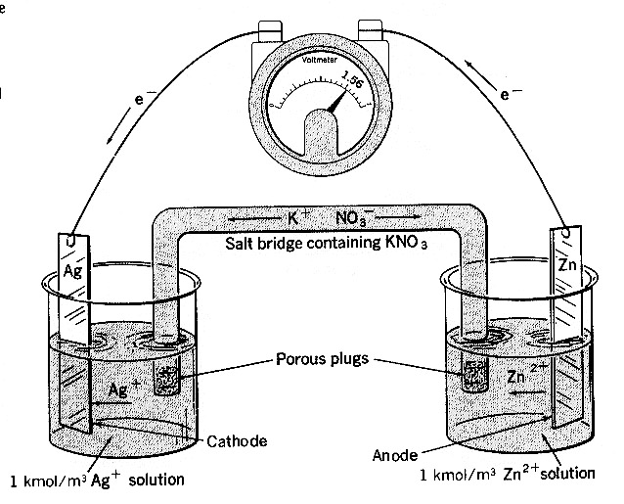

Eº = +0.80 V Ag⁺_{(aq)} + e⁻¹ ---> Ag_{(s)} reduction
Eº = +0.76 V Zn_{(s)} ---> Zn²⁺_{(aq)} + 2e⁻¹ oxidation
_________________________________
E_{cell} = +1.56 V 2 Ag⁺_{(aq)} + Zn_{(s)} ---- > 2Ag_{(s)} + Zn²⁺_{(aq)}

Question 17 (3 marks)

The condensed structural formula of a monomer is shown.

CH₂ = CHCl

(a) Identify the systematic name of this monomer. 1

…………………………………………………………………………………………

(b) Draw the structure of the polymer made from this monomer (showing 4 monomer units) 1

(c) What is the molecular weight of this polymer made from 4 monomers.? 1

…………………………………………………………………………………………..

Outcome H9

Sample Answer

  - chloroethene

(b)

……..- CH₂- CHCl-CH₂-CHCl-CH₂-CHCl-CH₂-CHCl-……

  - 249.8

Criteria | Marks
- Correctly names the monomer  - Correctly draws the structure for PVC showing 4 monomer units only  - Correctly calculates the molecular weight for the polymer drawn | 3
Two of above | 2
One of above | 1

Question 18 (5 marks)

(a) The value for the heat of combustion of 1-propanol is 2021 kJ mol⁻¹.
Calculate the theoretical volume of water that could be heated from 31ºC to 55ºC
if 5g of 1-propanol was used. 2

……………………………………………………………………………………………….............

………………………………………………………………………………………………..............

………………………………………………………………………………………………..............

..............................................................................................................................................................

...............................................................................................................................................................

(b) If 1-pentanol was used instead of 1-propanol would you expect that a greater or lesser
quantity of fuel could be used to heat the same volume of water by the same amount?
Explain your answer. 3

………………………………………………………………………………………………

………………………………………………………………………………………………

………………………………………………………………………………………………

………………………………………………………………………………………………

………………………………………………………………………………………………

………………………………………………………………………………………………

Outcome: H9

Sample answer

(a) Molar mass of 1-propanol = 60.094g
60.094g ethanol releases 2021kJ
Therefore 5g releases 2021 X 5/60.094 kJ = 168.15kJ =168,153 J (1 mark )

168153 = mass of water X 4.18 X (55-31)

Mass of water = 168153/100.32 =1676g

Therefore the theoretical volume of water that could be heated is 1676 ml

(a)
Criteria | Marks
- Correctly calculates the number of J or kJ released by 5g of 1-propanol  - Correctly calculates the volume of water that could be heated | 2
- Correctly calculates the number of J or kJ released by 5g of 1-propanol | 1

(b) A lesser quantity (No. of moles) of fuel could be used if 1-pentanol was used because it would be expected that 1-pentanol would have a greater heat of combustion per mole as it has more chemical
energy stored in the greater number of chemical bonds (longer chain length) which could
be released when the compound is combusted and new products are formed.

(b)
Criteria | Marks
- Identifies that a lesser quantity of 1-pentanol could be used  - Correctly identifies that 1-pentanol has a greater heat of combustion per mole than 1-propanol  - Gives a correct explanation for higher heat of combustion | 3
Two of above | 2
One of above | 1

Question 19 (4 marks)

(a) What is a transuranic element? 1

………………………………………………………………………………………………

………………………………………………………………………………………………

(b) Give one example of a transuranic element and describe where and how it is produced. 3

………………………………………………………………………………………………

………………………………………………………………………………………………

………………………………………………………………………………………………

………………………………………………………………………………………………

Outcome: H3, H13

Sample Answer
(a) Transuranic elements have an atomic number greater than 92.
(b) Neptunium is made in a nuclear reactor. U-238 is bombarded with neutrons which
produce U-239 which then decays by beta emission to neptunium-239

Criteria | Marks
- Defines a transuranic element  - Identifies an example of a transuranic element  - Correctly identifies where it is produced  - Correctly identifies how it is produced | 4
3 of the above | 3
2 of the above | 2
1 of the above | 1

Question 20 (4 marks)

One hazardous compound is sulfur dioxide.

(a) State one industrial source of sulfur dioxide. 1

.......................................................................................................................................................

Answer:

Combustion of coal to produce electricity. Metal smelters. Combustion of diesel.

Outcome criteria | Marks
Stating one industrial source of SO₂. | 1

(b) Write a balanced formulae equation to describe how sulfur dioxide may be formed 1

........................................................................................................................................................

Answer: S(s) + O₂(g) → SO₂(g)

Outcome criteria | Marks
Writing a balanced equation (including states). | 1

(c) Give two reasons why sulfur dioxide may be considered a pollutant. 2

...........................................................................................................................................................

..........................................................................................................................................................

SO₂(g) is a poisonous gas that may trigger asthma.

SO₂(g) may react with water to form acid rain.

Outcome criteria | Marks
Provides two examples of SO₂ acting as a pollutant. | 2
Provides one example of SO₂ acting as a pollutant. | 1

Question 21 (5 marks)

The graph shows the national trends in emissions of nitrogen oxides, volatile organic compounds,
sulfur dioxide and particulate matter in the United States over an approximately 50-year time frame.

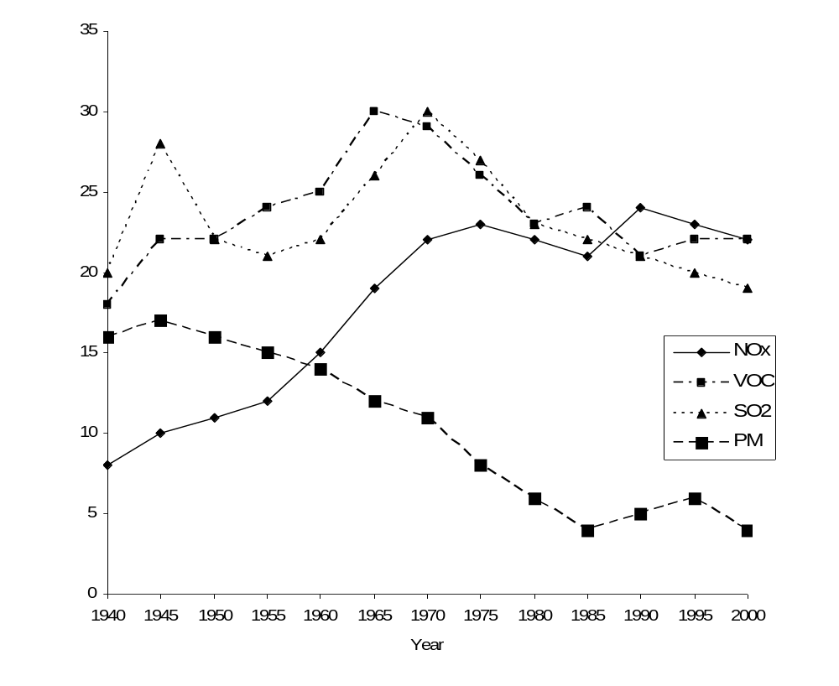
Figure USA national trends in emissions of nitrogen oxides, volatile organic compounds (VOC),
sulfur dioxide, and particulate matter (PM).

(a) Write the formula for one type of nitrogen oxide.
1

..........................................................................................................................................................

Answer:
NO₂, NO, N₂O₄

Outcome criteria | Marks
Provides one formula for a nitrogen oxide | 1

(b) Explain the trend observed for the emission of nitrogen oxides over the 50-year period. 2

..........................................................................................................................................................

..........................................................................................................................................................

..........................................................................................................................................................

..........................................................................................................................................................

Sample Answer:

There has been a gradual increase in the amount of nitrogen oxides emitted into the atmosphere over the past fifty years. This increase could be due to an increase in the use of motor vehicles and power stations; both of these are sources of nitrogen oxides as a result of the combustion of fuel using air. Air is predominately nitrogen, which reacts with oxygen in the combustion chambers of engines under high temperature and pressure to form nitrogen oxides

Outcome criteria | Marks
Identifies the graphical trend for nitrogen oxides + provides one reason for the trend. | 2
Identifies the graphical trend for nitrogen oxides. | 1

(c) Describe how you would assess the validity and reliability of above evidence for the
emission of nitrogen oxides. 2

..........................................................................................................................................................

..........................................................................................................................................................

..........................................................................................................................................................

..........................................................................................................................................................

Sample Answer

The sources of information provided for the graph would be investigated for their credibility. If the sources were university-based researchers using scientific means of obtaining data then the data would be valid (accurate). If other creditable sources of nitrogen oxide data reflect the same type of trend, then the information would be assessed as reliable (precise or reproducible). If the data from other sources differs, then the data would be treated as skeptical and treated with caution.

Outcome criteria | Marks
States one way of assessing information obtained from secondary sources in terms of validity and reliability. Students must distinguish between validity and reliability. | 2
States one way of assessing information obtained from secondary sources in terms of validity or reliability. | 1

V = validity mark R = reliability mark

“no link” = has not differentiated between validity and reliability.

“defined” = has not outlined how to assess; the student, rather, has provided a definition of validity or reliability.

Secondary sources thread

Validity: creditable source? Up-to-date?
Reliability: do other resources report similar results? “cross-reference with other sources”; “comparing…”; “cross check…”; “checking with other sources”.

Experimental thread

Validity: assess the method used to obtain the results. “examine the…”; researching the method…”.
Reliability: examine the consistency of repeat results: “how close repeats are” “judge the consistency of repeats”.

Question 22 (5 marks)

When Alka-Seltzer tablets are placed in water, a series of chemical reactions results in the formation
of carbon dioxide and water. The results of an investigation that examined the effects of temperature
on the solubility of carbon dioxide in water are displayed in the table.

 | Beaker 1 | Beaker 2 | Beaker 3 | Beaker 4
Volume of distilled water (mL) | 150 | 150 | 150 | 150
Mass of Alka-Seltzer tablets (g) | - | 2 | 2 | -
Volume of NaOH(aq) added (mL) | 0.5 | 0.5 | 0.5 | 0.5
Temperature of water (ºC) | 6 | 6 | 70 | 70
Amount of Bromothymol blue indicator added (mL) | 2 | 2 | 2 | 2
Colour of solution | light blue | yellow | colourless to light green | light blue

Information regarding the colours of bromothymol blue in acidic, neutral and alkaline solutions is given in the table below.

 | Colour change
Indicator | Highly acidic | Slightly acidic | neutral | Slightly alkaline | Highly alkaline
Bromothymol blue | Yellow | Yellow | Colourless to light green | Blue | blue

Explain how the results demonstrate the effect of temperature on the solubility of carbon dioxide
in water? 5

..................................................................................................................................................................

..................................................................................................................................................................

..................................................................................................................................................................

.................................................................................................................................................................

..................................................................................................................................................................

..................................................................................................................................................................

...................................................................................................................................................................

...................................................................................................................................................................

....................................................................................................................................................................

....................................................................................................................................................................

Sample Answer

Beakers 1 and 4 are light blue to the alkaline nature of the solution they contain; this means that temperature does not affect the acidity of the NaOH(aq)/indicator/water solutions. These beakers are controls for Beakers 2 and 3 respectively. The solutions are alkaline due to the NaOH(aq) added. Beaker 2 is acidic due to the CO₂ formed from the Alka Seltzer tablet reaction with water reacting with water to form carbonic acid. The neutral status of the solution in Beaker 3 is a result of the high temperature of the solution causing less CO₂ to dissolve, compared to Beaker 2, and thus there is less CO₂ to react with water to form carbonic acid.

Outcome criteria | Marks
(L): recognises that the solubility of CO₂ in water decreases with increasing temperature of solution. (Inverse relationship.) | 1
(T): Compares results of Beakers 2 and 3 in order to derive the impact of temperature on solubility of CO₂ in water. | 1
(A): explains acidity of solutions with CO₂: identifies carbonic acid as a product of CO₂ reacting with water (NOT dissolving with water). | 1
(I): Correct interpretation of indicator colours to acidity level of solutions. | 1
(C) Identifying the alkaline nature of the solutions in Beakers 1 and 4 (controls) as a baseline measure. Or, variables controlled when comparing Beakers 2 and 3. (V) | 1

Question 23 (4 marks)

A 0.126 mol L⁻¹ solution of a triprotic acid, H₃A, has a pH of 4.56.

(a) Is H₃A a weak or a strong acid? Justify your answer. 1

........................................................................................................................................................

........................................................................................................................................................

Outcomes: H10, H13

Sample Answer:

H₃A is a weak acid. A stronger acid should record a pH of approximately 1 for this
acid concentration,i.e., less than (-log₁₀ [0.126])

Criteria | Mark(s)
correct answer + justification | 1

(b) Calculate the volume of a 0.432 mol L⁻¹ NaOH which will react completely with
20.0 mL of the acid.. Show your working. 3

..................................................................................................................................................

..................................................................................................................................................

..................................................................................................................................................

...................................................................................................................................................

Outcome: H10

Sample Answer:

H₃A(aq) + 3 NaOH (aq) → Na₃A (aq) + 3 H₂O (l) 1 mark

moles NaOH = 3 x moles H₃A = 3 x 0.0200 x 0.126 = 7.56 x 10 ⁻³ mol 1 mark

Volume NaOH = 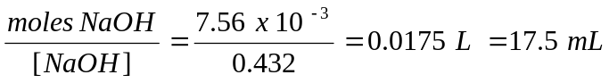 1 mark

Criteria | Mark(s)
correct calculations + equation | 3

Question 24 (3 marks)

Despite extreme care, Anne Koh, a top Chemistry student, spilled some concentrated
sulfuric acid on a school wooden bench. What chemical substance should Anne use to minimise
the damage to the table and lessen the associated hazard of the spilled concentrated acid?
Justify your choice by citing an appropriate desirable characteristics of the chemical of your choice.
Include in your answer a balanced chemical equation. 3

......................................................................................................................................................................

......................................................................................................................................................................

......................................................................................................................................................................

.......................................................................................................................................................................

........................................................................................................................................................................

Outcome: H11

Sample Answer:

Anne should sprinkle solid sodium hydrogen carbonate on the spilled acid until the effervescence stops. (1)

2 NaHCO₃ (s) + H₂SO₄(l) → Na₂SO₄(aq) + 2 H₂O(l) + 2 CO₂ (g) (1)

It is important to use solid NaHCO₃ so as not to dilute the sulfuric acid. NaHCO₃ is a good acid
neutraliser to use because of its weakly basic nature It is able to neutralise the concentrated acid
effectively without being corrosive, an excess of the sodium hydrogen carbonate can be used
without harm to the surrounding and the experimenter. (1)

Criteria | Mark(s)
correct choice of solid sodium hydrogen carbonate (also sodium carbonate) | 1
correct chemical equation (subscript not marked) | 1
any correct chemical property of sodium hydrogen carbonate | 1

Question 25 (2 marks)

Manny Tor is an industrial chemist employed by Hubba Industries to oversee the production
of ammonia by the Haber process. Two other chemists work with Manny to keep Hubba Industries
running.

Justify the collaboration between chemists in this industry. 2

..........................................................................................................................................................

..........................................................................................................................................................

Outcomes: H15

Collaboration between chemists is important in this industry because of the specialisation
of most chemists and the variety of expertise required(for rate vs. equilibrium adjustment,
– physical chemists, catalysts experts, analytical chemist to analyse raw materials (N_{2 and} H₂ for contamination and the purity of the ammonia produced).

Criteria | Mark(s)
2 or more valid reasons for collaboration in the Haber process industry | 2
2 or more valid reasons for collaboration but not specifically for this industry | 1

Question 26 (5 marks)

Several drinking water samples were to be analysed by AAS for their copper ion content.
The absorbance of each of the solutions were determined as well as the absorbance readings of
4 standard solutions. The result of the analysis is given in the table below:

Concentration of the standard (ppm) | Absorbance
1.00 | 0.240
2.00 | 0.319
3.00 | 0.402
4.00 | 0.478
Water Samples | Absorbance
X | 0.257
Z | 0.456
M | 0.579

(a) Use the grid below to construct a calibration curve for this analysis 2

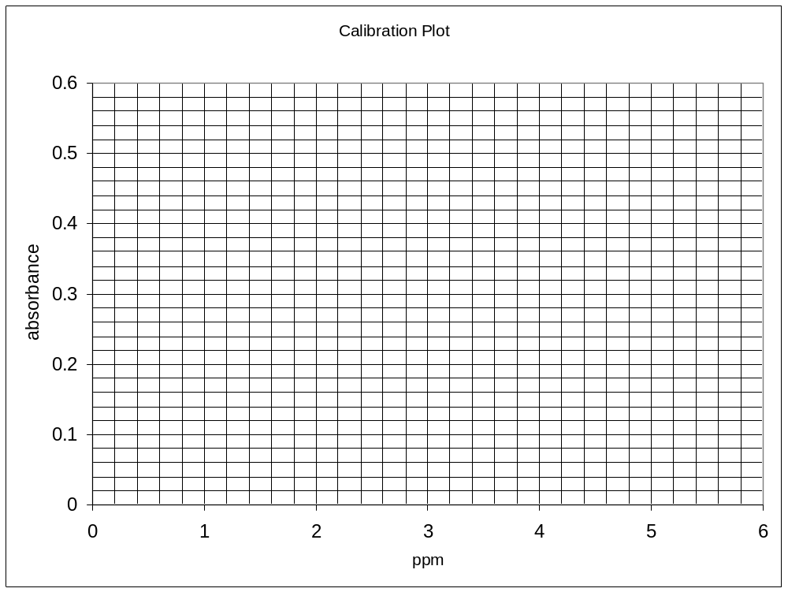

Outcomes: H13
Sample Answer:
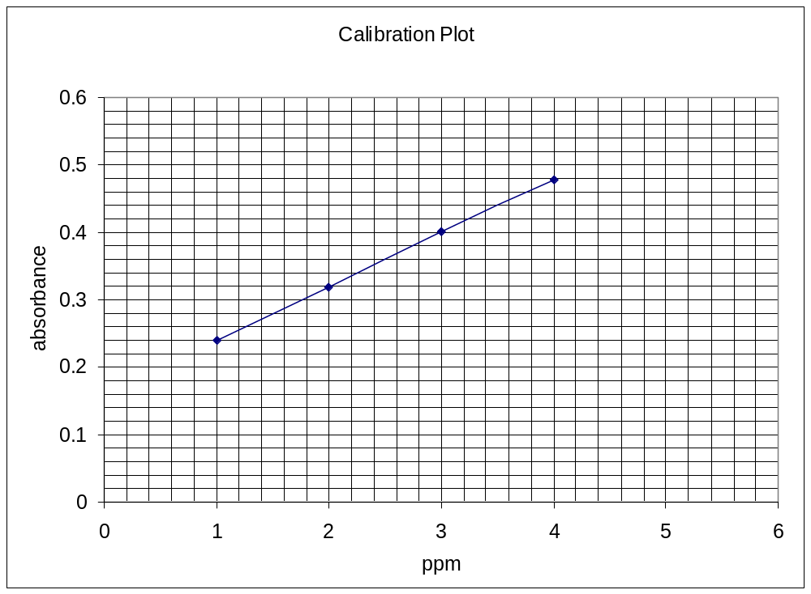

Marking Guidelines

Criteria | Mark(s)
Correct data plotting | 1
Line of best fit | 1

(b) Use the graph to determine the concentration of sample X, Z, and M. 1

Outcome:H13
Answer:

Sample X 1.20 ppm....... Sample Z ....3.7 ppm Sample M ....5.2 ppm

(c) Which of the results had the least validity? Explain your answer. 1

...............................................................................................................................................................

...............................................................................................................................................................

...............................................................................................................................................................

Outcome:H14
Answer:

Sample M had the least validity because it is an extrapolated value whereas samples X and Y were
interpolated values.

Criteria | Mark(s)
choice of M and reason for the choice | 1

Question 27 (6 marks)

Discuss the problems associated with the use of CFCs and evaluate the effectiveness of the use of the replacement chemicals to CFCs. 6

.................................................................................................................................................................

..................................................................................................................................................................

..................................................................................................................................................................

..................................................................................................................................................................

..................................................................................................................................................................

..................................................................................................................................................................

..................................................................................................................................................................

..................................................................................................................................................................

..................................................................................................................................................................

..................................................................................................................................................................

..................................................................................................................................................................

..................................................................................................................................................................

..................................................................................................................................................................

....................................................................................................................................................................

Outcomes: H4, H11, H12, H13, H14, H16

Sample Answer:

- CFCs are non-reactive carbon compounds containing carbon, chlorine and fluorine.
- These compounds have favourable energy of vapourisation and liquefaction that makes them ideal as refrigerants and unreactivity that makes them ideal as propellants
- Through diffusion, these compounds have reached the stratosphere where high energy radiation breaks them down releasing atomic chlorine
- atomic chlorine catalyses the destruction of stratospheric ozone
- reduced ozone layer results in increased UV penetrating the Earth’s atmosphere with adverse consequences to life on Earth, ( higher incidence of skin cancer, cataracts, etc)
- useful as they are, they are being replaced with HCFC (still capable of destroying ozone) and HFC (non-ozone destroying but a greenhouse gas)
- HCFCs and HFCs are more expensive but are less efficient than the CFCs
- Verdict: Replacements are less effective but are less harmful to the environment, hence are very much acceptable as an alternative.

Criteria | Mark(s)
statement of what CFCs are and their use(s) (W) | 1
statement of how they destroy the ozone layer (H) | 1
statement of effect of such destruction on UV B penetration of the Earth’s atmosphere (E₁) | 1
statement of the effect of such penetration on the life on Earth (E₂) | 1
description of replacements to CFCs (R) | 1
an evaluation statement on the effectiveness of these replacements (J) | 1

Question 28 (7 marks)

The diagram shows an outback region, Unnice valley, located just at the foot of a limestone mountain.
The region centres around a meandering river that goes out to sea at D. Water analysis was done at
points A, B, C and D as part of an environmental assessment of the feasibility of erecting a housing
development for the workers in the already existing industries in the area. Since the town is rather
remote, no town water supply is yet available. It is proposed that the residents obtain their
drinking water from bores, rainfall tanks and from the river. It is also envisaged that the river
would provide food (fish) and recreational facilities for the residents.
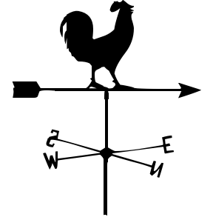
chicken farm
nuclear reactor
metal smelter
prevailing northerly wind winds
sea water
Unnice Valley
proposed housing development
A
B
C
D
N
to Limestone mountain
vegetable farm

Outcomes: H16, H4, H13, H16

Shown below is the experimental results of analysis of water samples at A,B,C and D

Substance/Area | A | B | C | D
Dissolved Oxygen (mg L⁻¹) | 8.0 | 8.0 | 3.0 | 2.0
Temperature (⁰ C) | 15 | 17 | 18 | 20
pH | 3.0 | 4.0 | 7.5 | 7.0
Cl⁻ (mol L⁻¹) | 10⁻⁴ | 10⁻⁴ | 10⁻³ | 0.3
Ca ²⁺ (mg L⁻¹) | 10 | 10 | 200 | 250
BOD | 3 | 3 | 200 | 300

(a) What is the possible cause of the observed river water pH in area A and B? Justify your
answer with an equation. 2

...........................................................................................................................................................

.........................................................................................................................................................

Sample answer:

The low pH could be due to the smelter emitting sulfur dioxide which forms acid rain that falls into the river.
(1 mark)

The possible reaction is : SO₂ + H₂O  H₂SO₃  H⁺ + HSO₃⁻ (1 mark)

Criteria | Mark
choice of the smelter as the cause of low pH and accompanying explanation | 1
equation | 1

(b) Explain the effect of high calcium ion concentration in the water sample obtained from C if
this water is used in the home. . 2

........................................................................................................................................................

..........................................................................................................................................................

..........................................................................................................................................................

Sample Answer:
High Ca²⁺ ion concentration in water constitutes hardness in water. This results in the development
of scum on equipment (deposition of calcium carbonate on the equipment) and the non-lathering of soap due to the precipitation of calcium ion with the soap.

Criteria | Mark
Effect of high calcium ion concentration | 1
Explanation of this effect | 1

(c) Assess the capacity of the river system to provide food and recreational facilities
(such as boating or swimming) for the residents of this proposed housing development. 4

.............................................................................................................................................................

..............................................................................................................................................................

...............................................................................................................................................................

..............................................................................................................................................................

..............................................................................................................................................................

...............................................................................................................................................................

Sample Answer:

- support of fish population depends on the dissolved oxygen in the river. The presence of the
nuclear reactor dumping its cooling water on the river (shown by the elevated temperature in C and D lowers the oxygen solubility and hence the dissolved oxygen.
  - the type of fish that can survive will be limited.
- the very high BOD due to the waste generated by the chicken farm makes the water
unsafe for swimming
•the low water pH in some parts discourages life and life diversity in the river, since most fish survive better at a pH of 6-8.

The verdict: the river is an unsatisfactory source of food. It is also unsuitable as a venue for recreation, especially swimming, for residents of this development.

Criteria | Mark
2 valid reasons on the capacity of the river to provide food and to be a recreational facility for the residents | 2
Judgment | 1

Outcomes: H16, H4, H13, H16

Section II

25 marks

Attempt question 29
Allow about 45 minutes for this section

Answer the question in a writing booklet. Extra writing booklets are available.
Show all relevant working in questions involving calculations.

Question 29

(a) During your practical work you performed a first hand investigation to observe the reaction of
sulfuric acid acting as an oxidizing agent.

(i) Identify a risk associated with this procedure. 1

(ii) Outline the procedure used and the results you obtained. 2

(b) Sulfur dioxide is converted to sulfur trioxide by the contact process.
Consider the following information.

2SO₂ (g) + O₂ (g)  2SO₃ (g) ΔH = – 198 kJmol⁻¹

 | Reactant Concentrations (mol L⁻¹) |  | Product Concentrations (mol L⁻¹)
550 ºC | SO₂ | O₂ | SO₃
Initial | 1.13 | 1.78 | 0
Final | 0.950 | x | 0.180

(i) Write the equilibrium constant expression for this reaction. 1

(ii) Determine the value of x and hence calculate the equilibrium constant. 3

(iii) Does the reaction favour the reactants or the products at 550 ºC?
Explain your answer. 1

(iv) Why is a temperature range of 500–600 ºC used in the contact process? 2

(c) Sodium hydroxide is manufactured from sodium chloride by electrolysis.

Describe the advantages and disadvantages associated with using a mercury cell to produce
sodium hydroxide. 4

(d) Soaps and detergents act as emulsifying agents when removing stains from materials, however,
they have different structures.

(i) Explain how soaps OR detergents act as emulsifying agents. 4

(ii) Distinguish between soaps and detergents in terms of their effect in hard water. 2
(e) The Solvay process is a series of reactions in the production of sodium carbonate.

(i) Identify one use of sodium carbonate. 1

(ii) Write an overall equation for the production of sodium carbonate from
sodium chloride and calcium carbonate. 1

(iii) Calculate the mass and volume of carbon dioxide produced at 25 ºC and 100 kPa
when 1000 kg of calcium carbonate is heated.. 3

Sample Answers and marking guidelines

(a) During your practical work you performed a first hand investigation to observe the
reaction of sulfuric acid acting as an oxidizing agent.

(i) Identify a risk associated with this procedure.

Sample answer

Sulfuric acid is very corrosive and protective gloves should be worn

Marking criteria | Marks
- Correctly identifies a risk associated with this procedure | 1

Outcomes H11

(ii) Outline the procedure used and the results you obtained.

Sample Answer

React zinc metal with concentrated sulfuric acid in a test tube in a fume cupboard.
The results show the zinc disappearing and gas bubbles being liberated.

Marking criteria | Marks
- Sketches in general terms the procedure used and results obtained | 2
- Sketches in general terms EITHER the procedure OR results | 1

Outcomes H11, H13

(b) Sulfur dioxide is converted to sulfur trioxide by the contact process.
Consider the following information.

2SO₂ (g) + O₂ (g)  2SO₃ (g) ΔH = –198 kJmol⁻¹

 | Reactant Concentrations mol⁻¹ |  | Product Concentrations mol L⁻¹
550 ºC | SO₂ | O₂ | SO₃
Initial | 1.13 | 1.78 | 0
Final | 0.950 | x | 0.180

(i) Write the equilibrium constant expression for this reaction. 1

Sample Answer

K = [SO₃]²
[SO₂]²[O₂]

Marking criteria | Marks
- Correctly writes the equilibrium constant expression | 1

Outcomes H10, H13

(ii) Determine the value of x and hence calculate the equilibrium constant.

Sample Answer

x = 1.78 - ½(0.180) = 1.69

K = [SO₃]²
[SO₂]²[O₂]

= 0.180²
0.950² x 1.69

= 0.0212

Marking criteria | Marks
- Gives the correct answer for the equilibrium constant showing the value for x and relevant working. | 3
- Correct working based on incorrect value for x  - Correct working based on correct x and incorrect gas concentrations | 2
- Correct value for x OR  - Gives the correct answer for the equilibrium constant | 1

Outcomes H10, H13

(iii) Does the reaction favour the reactants or the products at 550 ⁰C?
Explain your answer. 1

Sample Answer

K is less than one which means the numerator is less than the denominator or
concentration of products is less than concentration of reactants. This means that the
reactants are favoured.

Marking criteria | Marks
- Explains that reactants are favoured when K < 1 | 1

(iv) Why is a temperature range of 500 – 600 ⁰C used in the contact process? 2

Sample answer

Even though low temperatures would favour the forward reaction as it is exothermic, it is
very slow, so a compromise temperature of 500 – 600 ⁰C is used to increase the rate of reaction
so that equilibrium is reached faster.

Marking criteria | Marks
- Links compromise temperatures with reaction rate and equilibrium | 2
- Identifies 500 – 600 ºC temperature will increase reaction rate | 1

(c) Sodium hydroxide is manufactured from sodium chloride by electrolysis.

Outline the advantages and disadvantages associated with using a mercury cell to produce sodium
hydroxide.

Sample answer

Disadvantages : Some mercury is lost to the environment which has a negative
impact as mercury is bioaccumulative and toxic. The process is expensive and requires a lot
of energy
Advantages : The mercury process produces a high quality product and all the
products of electrolysis are used.
4
Marking criteria | Marks
- Outlines two advantages and two disadvantages | 4
- Outlines two advantages and one disadvantage OR  - Outlines one advantage and two disadvantages | 3
- Outlines two advantages OR two disadvantages  - Outlines one advantage AND one disadvantage  - Identifies advantages and disadvantages | 2
- Outlines one advantage OR one disadvantage | 1

Outcomes H3, H4. H13

(d) Soaps and detergents act as emulsifying agents when removing stains from materials, however,
they have different structures.

(i) Explain how soaps OR detergents act as emulsifying agents. 4

Sample answer

Emulsifiers allow immiscible materials to mix. Once the oil or grease is removed from
the material the soap acts as an emulsifying agent by keeping the droplets of oil in the water
where they can be carried away. The non-polar alkyl tail of the soap molecule forms dispersion
forces with the oil molecule. The tails bury themselves in the oil and the polar heads on the
outside of the droplet prevent the droplets from joining together (they repel each other). Thus
the oil droplets are suspended in the water.

Marking criteria | Marks
- Identifies polar and non polar ends of the soap/detergent molecule and explains their function in maintaining droplets suspended in the emulsion including hydrogen bonding and dispersion forces. | 4
- Outlines the action of soap/detergent as an emulsifying agent | 3
- Briefly outlines the action of soap/detergent as an emulsifying agent without key terms. | 2
- Identifies that emulsifiers allow immiscible materials to mix.  - Identifies polar and non polar ends of the soap/detergent molecule. | 1

Outcomes H4, H9

(ii) Distinguish between soaps and detergents in terms of their effect in hard water.

Sample answer

Soaps react with Ca and Mg ions in hard water to form precipitates that form a
grey scum and prevent the soap from lathering. Detergents do not form a scum with hard
water as the salts of these detergents are soluble.

Marking criteria | Marks
- Describes the effect of soaps AND detergents in hard water | 2
- Describes the effect of soaps OR detergents in hard water | 1

Outcomes H3, H4, H9

(e) The Solvay process is a series of reactions in the production of sodium carbonate.

(i) Identify one use of sodium carbonate. 1

Sample answers

Glass making, Making detergents and soaps, manufacturing paper, making other chemicals,
preparing textiles, washing soda

Marking criteria | Marks
- Identifies one use of sodium carbonate | 1

Outcomes H4

(ii) Write an overall equation for the production of sodium carbonate from sodium chloride and
calcium carbonate.

CaCO₃ + 2NaCl → Na₂CO₃ CaCl₂

Marking criteria | Marks
- Correct balanced equation, no subscripts required | 1

Outcomes H10

(iii) Calculate the mass and volume of carbon dioxide produced at 25⁰C and 100kPa when
1000kg of calcium carbonate is heated.

Sample answer

mol CaCO₃ = mass/fw = 1000 x 10³ / 100 = 10000 mol

mass CO₂ = mol x fw = 10000 x 44 = 440,000g = 440kg

V CO₂ = mol x 24.79 = 247.9 x 10³ L

Marking criteria | Marks
- Correct mass and volume with relevant working | 3
- Correct mass or volume with relevant working OR  - Correct mass and volume with incorrect mol CaCO₃ | 2
- Correct mass OR  - Correct volume OR  - Correct mol CaCO₃ | 1

Outcomes H9, H10

End of Test 

